November 2024 | Prayer Calendar
PROVIDENCE BAPTIST CHURCH OF SAN FRANCISCO  REVEREND DR. LEROY E. ADAMS, JR., PASTOR  1601 MCKINNON AVENUE  SAN FRANCISCO, CALIF. 94124  PHONE: 415-641-8719  FAX: 415-641-0775 | 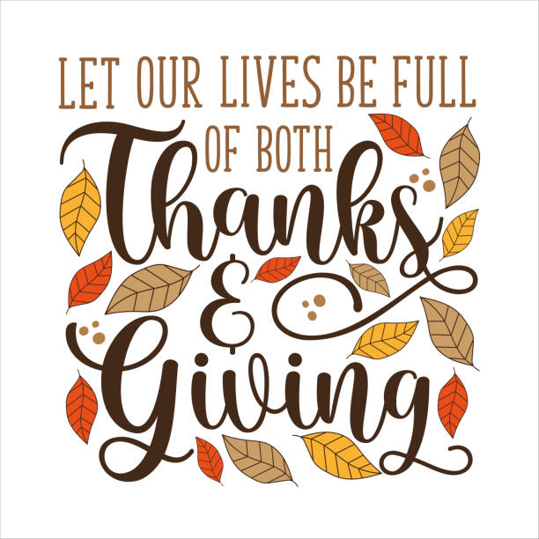  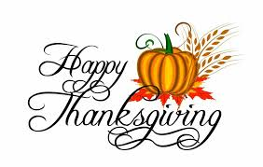
Sunday | Monday | Tuesday | Wednesday | Thursday | Friday | Saturday
 |  |  |  |  | 1 | 2
 |  |  |  |  | Hosea 9:7 | 1 Thessalonians  1:3
3 | 4 | 5 | 6 | 7 | 8 | 9
Job 16:5 | Psalm 23:4 | Ruth 2:13 | Isaiah 12:1 | Jeremiah 31:13 | Isaiah 49:13 | Zechariah 1:13
10 | 11 | 12 | 13 | 14 | 15 | 16
Psalm 25:9 | Proverbs 11:3 | Matthew 15:14 | Proverbs 16:23 | Psalm 23:2-4 | Matthew 23:16 | Matthew 23:24
17 | 18 | 19 | 20 | 21 | 22 | 23
Job 5:16 | Proverbs 11:23 | Hosea 2:15 | Micah 7:7 | Luke 23:8 | Acts 2:26 | Romans 5:4-6
24 | 25 | 26 | 27 | 28 | 29 | 30
Numbers 6:26 | Leviticus 26:6 | 1 Samuel 1:17 | Judges 18:6 | Job 21:13 | Psalm 29:11 | Job 20:3

